Online Guide for Sec 3 Subject Combinations

Website: https://sgs.schoolhub.sg

Login

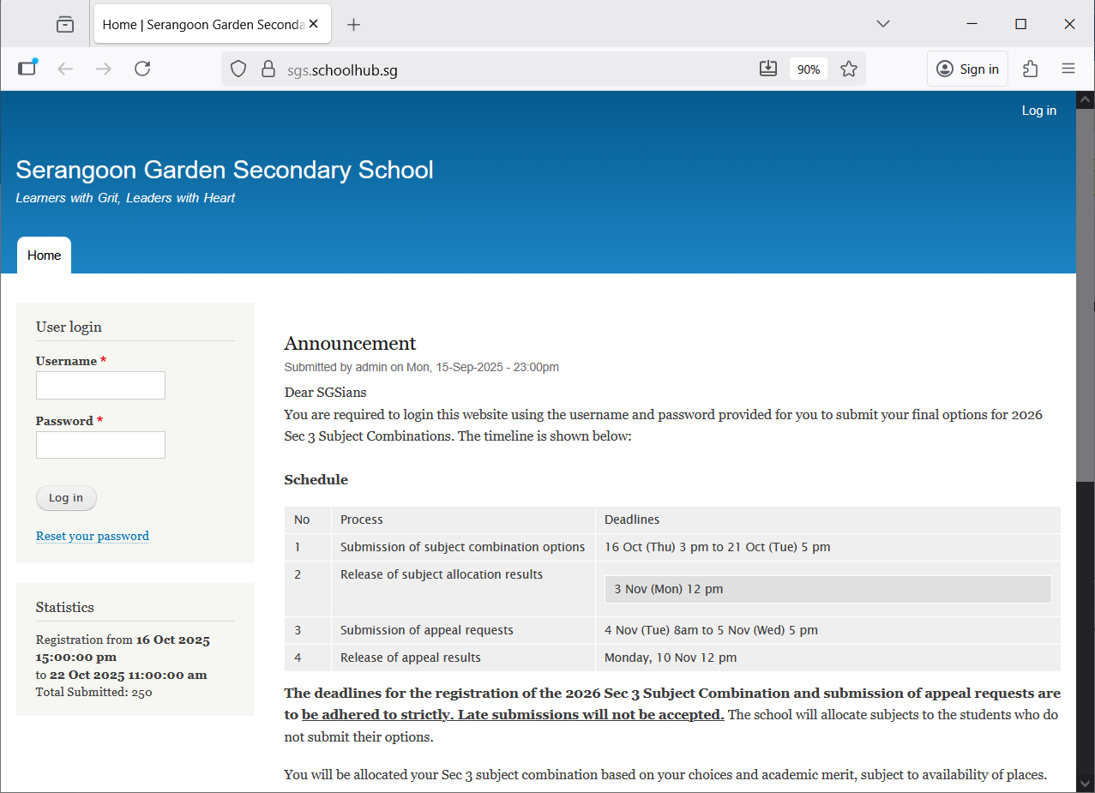
Click Log in
Enter Username
Enter Password

Check Placement

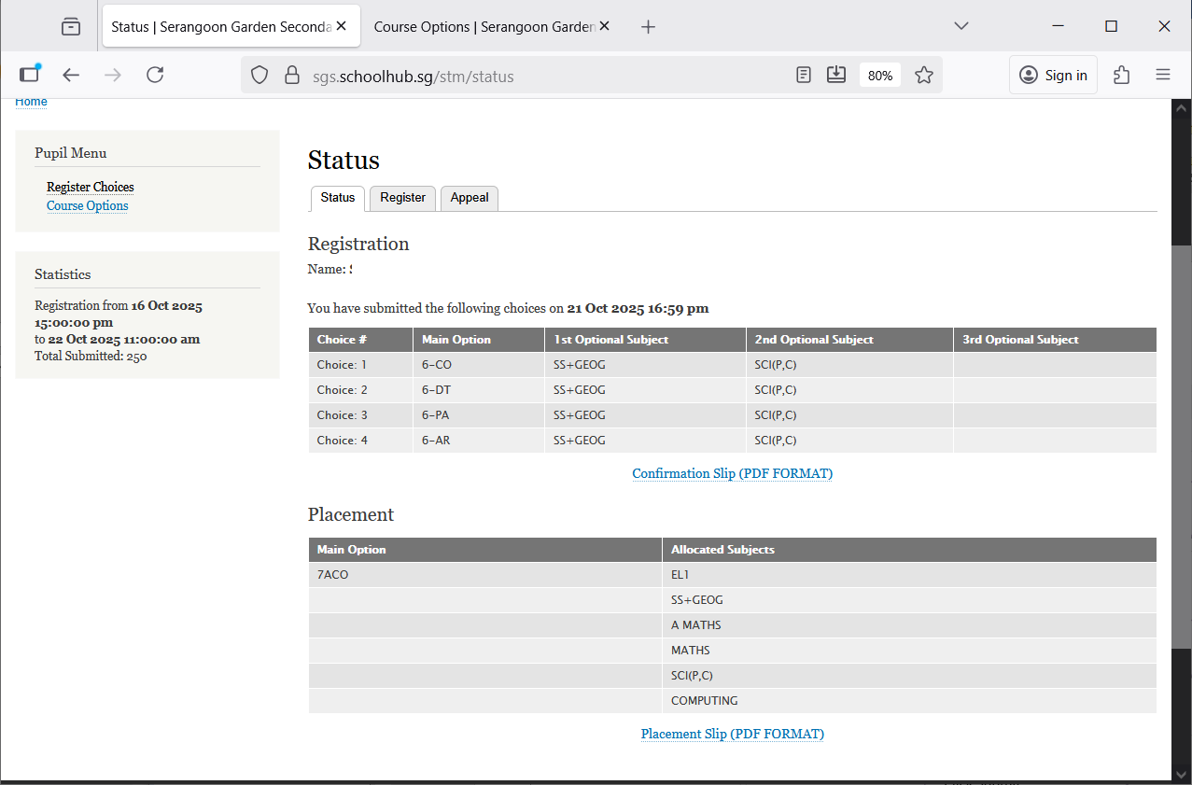
If you want to appeal for subjects not allocated to you.
Check Subject allocated

Make Appeal

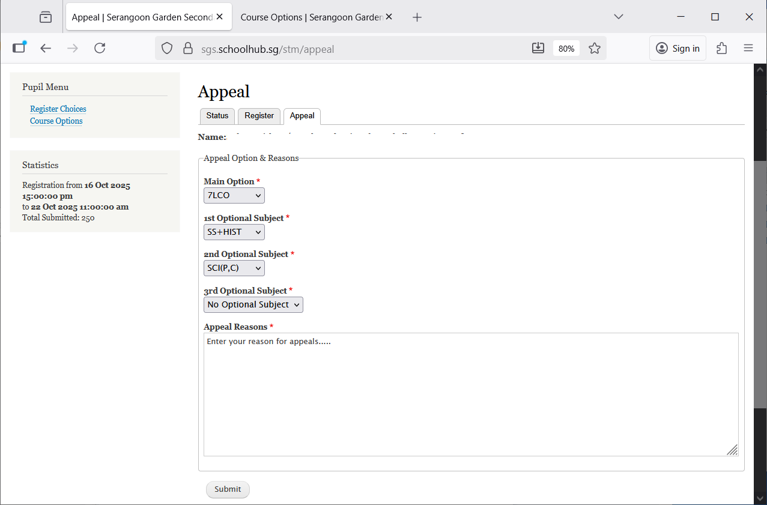
Click Submit
Enter Reasons for appeals
Enter Choices to appeal

